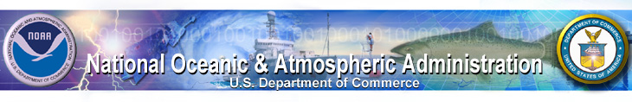

GENERAL INFORMATION

19th North America-Europe Data Exchange Meeting

Silver Spring, Maryland May 3-5, 2006

Date: Wednesday, May 3 to Friday May 5, 2006

Host organization: National Oceanic and Atmospheric Administration (NOAA)
U.S. Department of Commerce

Venue: NOAA Headquarters
Room 1311-B
1315 East West Highway
Silver Spring, Maryland 20910

NOAA point of contact: Luisa Blanchfield, International Relations Specialist
ph: (301) 713-2024 ext. 207
fax: (301) 713-2032 email: Luisa.Blanchfield@noaa.gov

Presentations: If you would like to give a presentation, please answer the appropriate questions on the attached Registration Form. Typically each organization gives a status report of approximately 30 minutes. If you need a longer or shorter amount of time, please indicate this on the form and we will work to accommodate you. We would like to have a copy of the presentations at least three days in advance of the meeting.

Accommodations: Attached is a document with the rates, locations, and contact information for several hotels in the Washington, DC/Silver Spring area. DC is very busy in the springtime and therefore we recommend making your hotel reservations as quickly as possible to ensure you can stay at your first choice at a reasonable price. We ask that you complete the Registration Form, which includes your travel & accommodations information, so we know when you arrive and where you are staying.

Transportation to venue: Unfortunately, we are unable to provide transportation to and from the NOAA complex in Silver Spring each morning/afternoon. If you favor being close to the meeting venue, the Silver Spring Hilton is within short walking distance, and the Crowne Plaza in Silver Spring has a shuttle that will drop guests off at the Metro Station (close to where NOAA is located). NOAA is on the Red Line of the DC metro system, and we have recommended hotels near Red Line stops to ensure a faster commute. Also included is a map of the DC Metro system.

Questions? If you have any questions or comments on any of the above issues please contact Luisa Blanchfield. More logistical details will follow (meeting times, agenda, etc).

**Please remember to fill out the attached Registration Form and return to
Luisa Blanchfield (preferably by email or fax) as soon as possible or by April 14, 2006**

